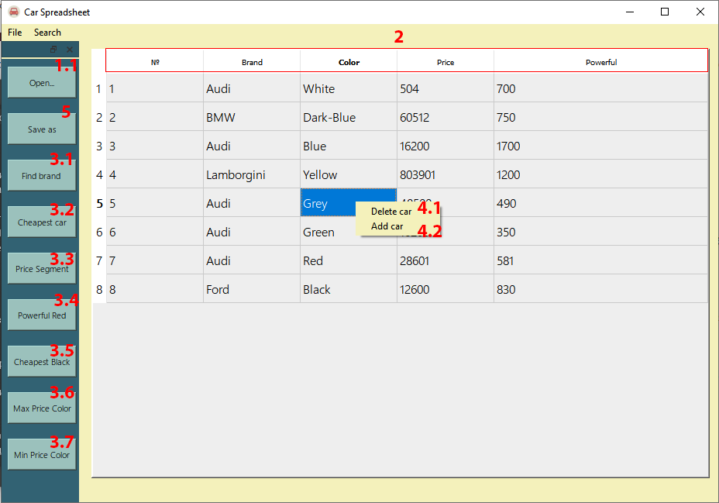**User Instruction**

*Img.1*

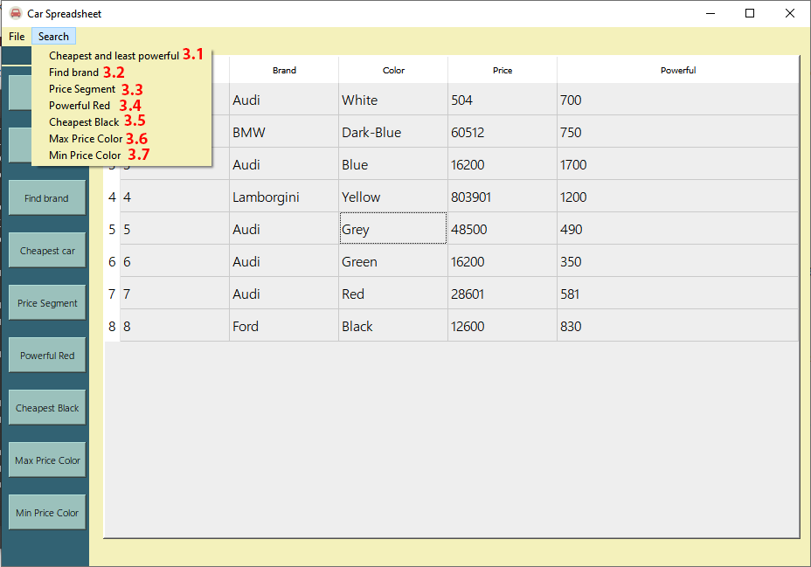

*Img.2*

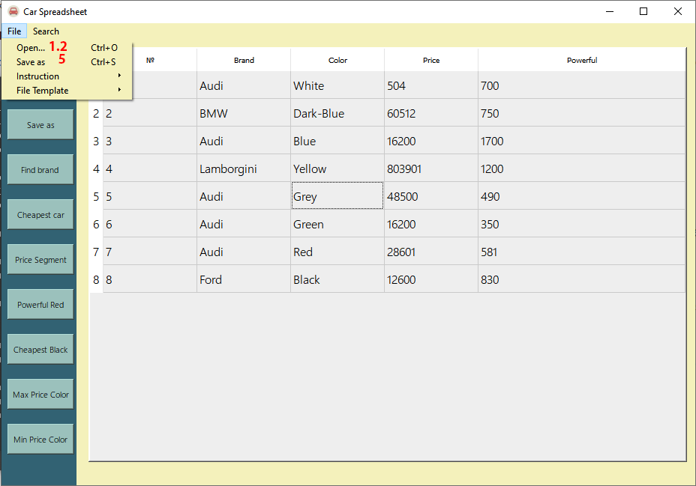

*Img.3*

To start working with the program, you need to run the file carSpreadsheet.exe. Now we can work with our program.

1. Getting started

You have two ways to get started with your data.

1.1.Adding an item manually. To add an item to the table, you need to click RMB on the table. After that, a context menu will appear where you need to select the Add car button. Then will appear a dialogue box where you need to fill in all the fields and click OK. If you do not need to add a new item, click Cancel. If a warning appears when you click OK, you did not fill in all the fields or entered incorrect information. After that, yours will appear in the table item, and you can work with it.

1.2.Reading from a file. To read from a file, you can click the Open .. button in the block or press the File->Open button on the taskbar or use the Ctrl + O hotkeys. Then a dialogue will open a window where you need to find your input file. About the correct filling of the input file, you can read in the file File Example.txt. After opening this File, all data will be displayed in the table.

2. Data sorting

To sort items by a specific criterion, click on the appropriate table header. All items are sorted in ascending order by clicking on the title (№, Brand, Color, Price or Power). By clicking on the same title again, the items are sorted in descending order.

3. Search for data

3.1.Find brand. By clicking this button in the block or on the taskbar, the car brands will be displayed in the table with the same price and different colors. If such cars are not found, a warning will appear it. To return to the previous tables, click the Back button on the left lower corner.

3.2.Cheapest car. Clicking this button in the block or on the taskbar will bring up a dialogue box where you need to enter the car brand. After that, the table will display the cheapest and least powerful (simultaneously) cars. If such cars are not found, a message will appear. To return to the previous table, click on the Back button located in the lower-left corner.

3.3.Price Segment. Clicking this button in the block or on the taskbar will bring up a dialogue box where you must enter the beginning at the end of the price segment. After that, the table will display the car, the price which is within the specified limits. If such cars are not found, a message will appear. To return to the previous tables, click the Back button in the lower-left corner.

3.4.Powerful Red. Clicking this button in the block or on the taskbar will be displayed in the table the most powerful red car for each brand. If such cars are not found, it will appear message about it. To return to the previous tables, click the Back button, which is in the lower-left corner.

3.5.Cheapest Black. Clicking this button in the block or on the taskbar will display the cheapest black car for each brand in the table. If such cars are not found, it will appear message about it. To return to the previous tables, click the Back button, which is in the lower-left corner.

3.6.Max Price Color. By clicking this button in the block or on the taskbar, the table will display auto, with the maximum price for each color. To return to the previous tables, click on the Back button, which is located in the lower-left corner.

3.7.Min Price Color. The table will display auto by clicking this button in the block or on the taskbar, with a minimum price for each color. To return to the previous tables, click on the Back button located in the lower-left corner.

4. Data change

4.1.Removal of the element. To delete a specific item, click RMB on that item in the table. Then a context menu will appear where you need to select the Delete car button. As a result, this element will disappear from the table.

4.2.Adding an item. This procedure has already been described above. Refer to section 1.1. and follow the steps below.

4.3. Changing an existing element. Double-click on the field you want to change in this item, change the data and press Enter. As a result, the data of this element will be changed.

5. Saving data

To save the data from the table, click the Save as button in the block or click the File -> Save as button. On the taskbar, or use the Ctrl + S hotkeys. Next, select the path where your File and will be located name. By clicking OK, the File will be saved.